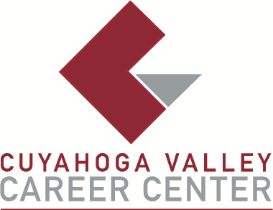

**TO:** Area Media

**FOR IMMEDIATE RELEASE**

Monday, October 7

**CONTACT:**

Julie Jakubczak

Cuyahoga Valley Career Center

8001 Brecksville Road

Brecksville, Ohio

jjakubczak@cvccworks.edu

440.746.8240

**CVCC Will Host Craft Show on Saturday, November 2, 2024**

Brecksville, OH – Cuyahoga Valley Career Center (CVCC) is hosting a Craft Show on Saturday, November 2, 2024, from 9:00 a.m. to 3:00 p.m. The event will feature numerous vendors offering unique gifts, handcrafted items, and baked goods. Admission is $1. The Craft Show is the largest fundraising event for the SkillsUSA Local Chapter. All proceeds will support leadership activities and programming throughout the year. CVCC hopes to see you there!

Sponsored by the SkillsUSA Local Chapter, crafters interested in participating can reserve a space. One space costs $50, two spaces cost $85, and three spaces cost $105. Space is allocated on a first-come, first-served basis. Checks should be made payable to CVCC/SkillsUSA. No applications or payments will be accepted after October 25, 2024. To reserve a space or for more information, contact Mrs. Julie Jakubczak at (440) 746-8240 or jjakubczak@cvccworks.edu.

The Cuyahoga Valley Career Center is located at 8001 Brecksville Road, Brecksville, OH 44141. The school driveway is opposite Wallings Road on Brecksville Road (Rt. 21). CVCC serves the public-school districts of Brecksville-Broadview Heights, Cuyahoga Heights, Garfield Heights, Independence, Nordonia Hills, North Royalton, Revere, and Twinsburg.

###