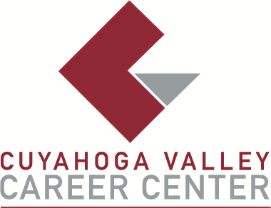

**TO:** Area Media

**FOR IMMEDIATE RELEASE**

January 29, 2025

**CONTACT:**

Michael Hall, Principal

Cuyahoga Valley Career Center

8001 Brecksville Road

Brecksville, Ohio

mhall@cvccworks.edu

440.746.8281

**CVCC DISTINGUISHED ALUMNI AWARD NOMINATION**

Brecksville, OH – The Cuyahoga Valley Career Center (CVCC) is seeking candidates for its Distinguished Alumni Award for exemplary accomplishment in and contribution to industry, community and education. Candidates should have completed a one or two-year CVCC high school program or an entire adult education workforce development program in 2015 or earlier. This award recognizes the outstanding career achievements in a profession that is closely related to the training received at CVCC.

Nominations are due no later than Friday, March 14, 2025. The official nomination form is available at [www.cvccworks.edu](http://www.cvccworks.edu). CVCC will be honoring the recipients of this award at the Senior Recognition Ceremony on Wednesday, May 7, or on Thursday, May 8, 2025. For any questions or inquires please contact Michael Hall at (440) 746-8281. Completed forms can be e-mailed to mhall@cvccworks.edu or mailed to Michael Hall, Principal at Cuyahoga Valley Career Center, 8001 Brecksville Road, Brecksville, Ohio 44141.

Cuyahoga Valley Career Center is located at 8001 Brecksville Road, Brecksville, Ohio 44141. The school drive is opposite Wallings Road on Brecksville Road (Rt. 21). Cuyahoga Valley Career Center serves the public-school districts of Brecksville-Broadview Heights, Cuyahoga Heights, Garfield Heights, Independence, Nordonia Hills, North Royalton, Revere, and Twinsburg. Adult and Student Workshops and Adult Education courses are open and available to all residents of Northeast Ohio.

###