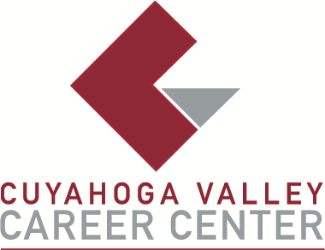

**TO:** Area Media

**FOR IMMEDIATE RELEASE**

February 13, 2025

**CONTACT:**

Josh Hayes

JHayes@cvccworks.edu

Cuyahoga Valley Career Center

8001 Brecksville Road

Brecksville, OH 4414

440-746-8260

**JOB FAIR AT CVCC IS THURSDAY, MARCH 6, 2025**

**Brecksville, OH** - Cuyahoga Valley Career Center (CVCC) will host a Job Fair on Thursday, March 6, from 3:00 p.m. to 5:00 p.m. CVCC invites all job seekers age 14 and older to attend. This event will be held at CVCC and is free for job seekers, registration is not required. Area businesses and non-profit organizations will be on site to interview potential employees for full-time, part-time and seasonal employment opportunities. If you plan to attend, dress professionally and bring multiple copies of your resume, along with pen and paper. Be prepared to fill out applications and interview with prospective employers. We hope to see you there! For more information, including job fair tips and a list of participating businesses and organizations, visit cvccworks.edu or contact Josh Hayes at JHayes@cvccworks.edu or 440-746-8260**.**

Cuyahoga Valley Career Center serves the public school districts of Brecksville-Broadview Heights, Cuyahoga Heights, Garfield Heights, Independence, Nordonia Hills, North Royalton, Revere and Twinsburg. Adult and Student Workshops and Adult Education courses are open and available to all residents of Northeast Ohio. The Career Center is located at 8001 Brecksville Road, Brecksville, OH 44141, one mile east of the I-77/Wallings Road exit, opposite Wallings Road on Rt. 21.

###