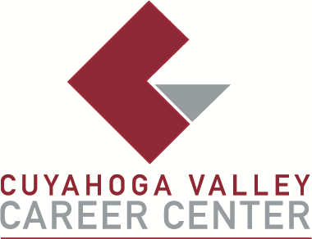

TO: Area Media

FOR IMMEDIATE RELEASE
December 1, 2025

CONTACT:
Kelli Casini
Admissions Counselor (High School)
kcasini@cvccworks.edu
Cuyahoga Valley Career Center
8001 Brecksville Road
Brecksville, Ohio 44141
440-746-8286

CVCC STUDENT AND PARENT INFORMATION NIGHT IS JANUARY 15, 2026

Brecksville, OH - Cuyahoga Valley Career Center (CVCC) will hold its annual Student and Parent Information Night on Thursday, January 15, from 7:00 p.m. to 8:30 p.m. for high school students and their families to learn more about the specialized career and college preparation opportunities available through the nearly 30 career-technical programs offered at CVCC. Attendees will be able to see programs, meet instructors, and ask questions. The Student and Parent Information Night helps with the decision-making process in choosing to enroll at the career center. Many CVCC programs offer industry certification opportunities and have career-technical credit transfer options, enabling students to earn college credit while at CVCC. Visit www.cvccworks.edu, or contact Kelli Casini, CVCC Admissions Counselor, at 440-746-8286 or kcasini@cvccworks.edu, with any questions.

Cuyahoga Valley Career Center is located at 8001 Brecksville Road, Brecksville 44141. The school drive is opposite Wallings Road on Brecksville Road (Rt. 21). Cuyahoga Valley Career Center serves the public-school districts of Brecksville-Broadview Heights, Cuyahoga Heights, Garfield Heights, Independence, Nordonia Hills, North Royalton, Revere, and Twinsburg. Adult Education programs are enrolling now and available to all residents of Northeast Ohio.

###

