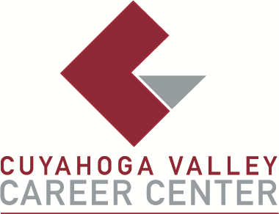

TO: Area Media

FOR IMMEDIATE RELEASE
January 23, 2026

CONTACT:
Josh Hayes
Assistant Principal
JHayes@cvccworks.edu
Cuyahoga Valley Career Center
8001 Brecksville Road
Brecksville, OH 4414
440-746-8260

JOB FAIR AT CVCC IS THURSDAY, MARCH 5
Brecksville, OH – Cuyahoga Valley Career Center (CVCC) will host a public Job Fair on Thursday, March 5, from 3:00 p.m. to 5:00 p.m. CVCC invites job seekers aged 14 and older to attend and explore a variety of employment opportunities. This free event will be held at CVCC, and no registration is required. Local businesses and non-profit organizations will be on site, offering interviews for full-time, part-time, and seasonal positions. Attendees are encouraged to dress professionally, bring multiple copies of their resume, and be ready to complete applications and interview with potential employers. For more information, contact Josh Hayes at JHayes@cvccworks.edu or 440-746-8260.
Cuyahoga Valley Career Center serves the public school districts of Brecksville-Broadview Heights, Cuyahoga Heights, Garfield Heights, Independence, Nordonia Hills, North Royalton, Revere, and Twinsburg. Adult Education courses are enrolling now and are available to all residents of Northeast Ohio. CVCC is located at 8001 Brecksville Road, Brecksville, OH 44141, just one mile east of the I-77/Wallings Road exit, across from Wallings Road on Route 21.
###

