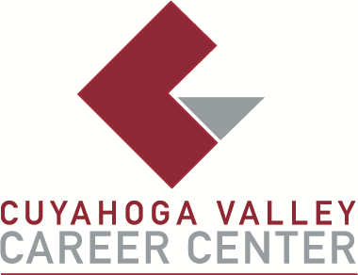

TO: Area Media
FOR IMMEDIATE RELEASE
February 17, 2026

CONTACT:
Michael Hall, Principal
Cuyahoga Valley Career Center
8001 Brecksville Road
Brecksville, Ohio
mhall@cvccworks.edu
440.746.8281

CVCC DISTINGUISHED ALUMNI AWARD NOMINATION

Brecksville, OH – The Cuyahoga Valley Career Center (CVCC) is seeking candidates for its Distinguished Alumni Award for exemplary accomplishment in and contribution to industry, community and education. Candidates should have completed a one or two-year CVCC high school program or an entire adult education workforce development program in 2016 or earlier. This award recognizes the outstanding career achievements in a profession that is closely related to the training received at CVCC.
Nominations are due no later than Friday, March 13 to be considered for the May 2026 award. The official nomination form is available at www.cvccworks.edu. CVCC will be honoring the recipients of this award at the Senior Recognition Ceremony on Thursday, May 7 or on Friday, May 8. For any questions or inquires please contact Michael Hall at (440) 746-8281. Completed forms can be e-mailed to mhall@cvccworks.edu or mailed to Michael Hall, Principal at Cuyahoga Valley Career Center, 8001 Brecksville Road, Brecksville, Ohio 44141.
Cuyahoga Valley Career Center is located at 8001 Brecksville Road, Brecksville, Ohio 44141. The school drive is opposite Wallings Road on Brecksville Road (Rt. 21). Cuyahoga Valley Career Center serves the public-school districts of Brecksville-Broadview Heights, Cuyahoga Heights, Garfield Heights, Independence, Nordonia Hills, North Royalton, Revere, and Twinsburg. Adult and Student Workshops and Adult Education courses are open and available to all residents of Northeast Ohio.
###

