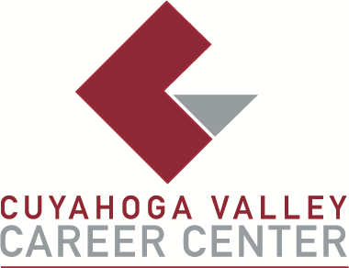

TO: Area Media

FOR IMMEDIATE RELEASE
March 3, 2026

CONTACT:
Lisa Theodore
Dental Assisting Instuctor (High School)
ltheodore@cvccworks.edu
Cuyahoga Valley Career Center
8001 Brecksville Road
Brecksville, Ohio 44141
440-746-8259
CVCC Becomes First Career-Tech School Invited to Safe Smiles
The Safe Smiles program in Cleveland, organized by the Greater Cleveland Dental Society, is a community initiative dedicated to promoting oral health and preventing sports-related dental injuries. The program provides free, custom-fitted mouth guards to local high school football players in a supportive, educational environment. This year marked a special milestone, as Cuyahoga Valley Career Center (CVCC) was the first career and technical school invited to participate in Safe Smiles. Our senior Dental Assisting students had the incredible opportunity to work alongside dental students under the supervision of Greater Cleveland Dental Society members and residents from area programs.
The event, held at Willoughby South High School on Saturday, February 28, began with an orientation. During this session, Dr. Tom Coreno and Dr. Sam Taylor reviewed proper impression techniques, what constitutes an accurate impression, and the various types of mouth guards available to athletes. This discussion reinforced the important role dental assistants play in patient education, especially when helping patients understand their options for protecting their teeth during sports activities. Over 70 student-athletes from Charles F. Brush High School, Kirtland High School, and Willoughby South High School arrived, with 8–10 stations set up for efficient workflow. Representing CVCC were seniors Olivia Albrecht (Twinsburg High School), Holly Gayner (Revere High School), Isaiah Kirkpatrick (Twinsburg High School), Simar Laly (Twinsburg High School), Lily Sobieski (Nordonia High School), Elizabeth Werner (North Royalton High School), and Diana Zgurska (North Royalton High School), along with Ms. Theodore. Throughout the day, students evaluated mouth sizes for trays, mixed alginate, maintained organized workspaces, and successfully took impressions for athletes participating in local flag football teams.
The program, led by Dr. Tom Coreno and Dr. Sam Taylor, also provided an opportunity to collaborate with area employers who support the CVCC Dental Assisting program. Our seniors had a fun-filled, hands-on learning experience and demonstrated exceptional professionalism. Feedback from organizers and participants was overwhelmingly positive—many commented on how professional and impressive the students were and expressed enthusiasm about having CVCC return to participate again next year. Thank you to the Safe Smiles program for providing CVCC with this incredible opportunity!
###

