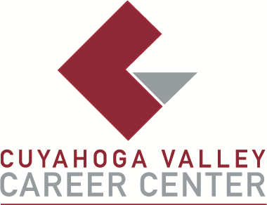

TO: Area Media
FOR IMMEDIATE RELEASE
Wednesday, April 15

CONTACT:
Bernadette Bodnar
Cuyahoga Valley Career Center
8001 Brecksville Road
Brecksville, Ohio
bbodnar@cvccworks.edu
440.746.8275
Cuyahoga Valley Career Center Participates in 2026 Northeast Ohio Transition Expo
Cuyahoga Valley Career Center (CVCC) is proud to support and participate in the 2026 Northeast Ohio Transition Expo, taking place on Saturday, April 25, 2026, from 9:00 a.m. to 12:00 p.m. at the Independence Civic Center.
Now in its 26th year, the Transition Expo is a long-standing community event designed to support transition-aged youth with disabilities and their families as they prepare for life after high school. The Expo brings together a wide range of organizations offering resources in employment, education, recreation, housing, assistive technology, and independent living.
CVCC will be represented at the event by Bernadette Bodnar, External Transition Coordinator, who has been a dedicated member of the Expo’s planning committee for more than 20 years. Her longstanding involvement reflects CVCC’s deep commitment to supporting students and families beyond the classroom.
Following the Expo, attendees are invited to stay for “On My Way,” a panel discussion from 12:00–1:00 p.m. featuring individuals sharing their personal journeys into adulthood after high school. The session is open to teens and adults, with lunch provided while supplies last.
The event is free and open to the public, welcoming individuals with disabilities, families, caregivers, and professionals from across Northeast Ohio. CVCC is honored to be part of this impactful event and remains committed to empowering students with the skills, support, and connections they need for a successful future.
###

